Miblock API Documentation

- Create Component API: This API will create the component, definition and records for that site.
Endpoint: /api/MiblockApi/CreateComponent
Method: POST
Headers:
- ms_cms_clientapp: This header specifies the client application making the request and is set to ProgrammingApp.
- Authorization: This header typically handles authentication. It appears to use a bearer token, but you've used @cookieValue as a placeholder. In practice, you would replace @cookieValue with a valid bearer token. Bearer tokens are often used for authentication and authorization purposes, allowing the client to access protected resources.

Note: Authorization should have bearer with the key.
This means that the client application should handle authentication by first logging in to the CMS backend to obtain the necessary token (in this case, the mscmswt cookie value), and then use that token in the Authorization header for subsequent requests.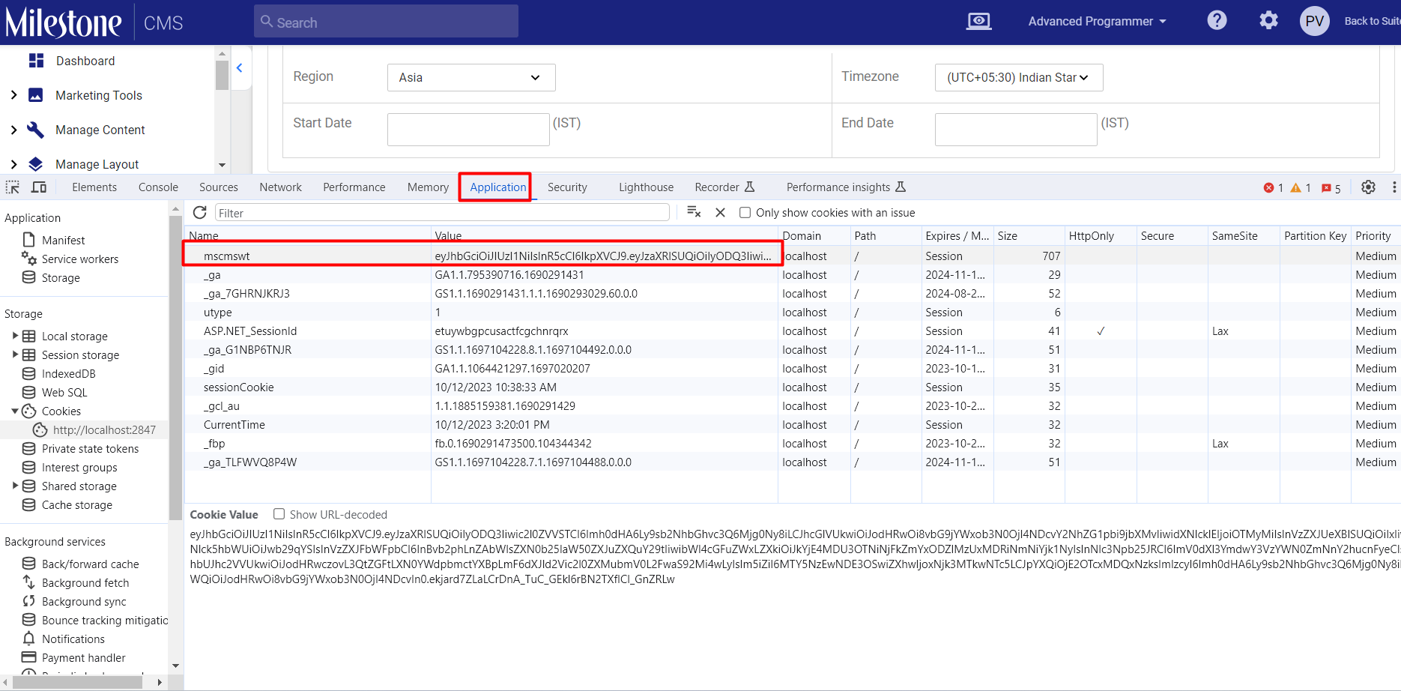

Body:
Sample Request:
{
"componentDetails":{
"component":{
"componentName":"Component 1",
"minRecord":1,
"maxRecord":50
},
"definitionList":[
{
"propertyName":"Title",
"propertyAliasName":"title"
},

],
"recordList":[
{
"recordJsonString":"\"{\"title\":\"Create Record 1 API\",\"description\": \"Create Record 1 Description\", \"long-description\": \"Create Record 1 Long Description\"}\""}
}
]
}

}

Sample Request 2:
{
"componentDetails": {
"component": {
"componentName": "Miblock-API-Ramada-5"
},
"definitionList": [
{
"propertyName": "title",
"propertyAliasName": "title",
"showInGrid":true,
"isIdentifier":true
},
{
"propertyName": "header",
"propertyAliasName": "header",
"controlName": "Text Input",
"showInGrid":true
},
{
"propertyName": "short description",
"propertyAliasName": "short-description",
"controlName": "Text Area",
"propertyMaxLength" : 100
},
{
"propertyName": "description",
"propertyAliasName": "description",
"controlName": "Rich Text Editor",
"propertyMaxLength" : 400
},
{
"propertyName": "Gender",
"propertyAliasName": "gender",
"controlName": "Radio Button",
"PropertyValue":"Female,Male"
},
{
"propertyName": "Salary",
"propertyAliasName": "salary",
"controlName": "Check Box",
"PropertyValue":"Above 50000,Below 25000"
},
{
"propertyName": "Image",
"propertyAliasName": "image",
"controlName": "File",
"resourceTypeName": "Main Images"
},
{
"propertyName": "Image-1",
"propertyAliasName": "image-1",
"controlName": "File",
"resourceTypeName": "Header Images"
},
{
"propertyName": "Birth Date",
"propertyAliasName": "birth-date",
"controlName": "Date Picker"
},
{
"propertyName": "Country",
"propertyAliasName": "country",
"controlName": "Dropdown",
"PropertyValue":"india,pakistan,nepal"
}
],
"recordList":[
{
"recordJsonString": "\"{\"title\": \"Title API 2.1\", \"header\": \"Header API 2.1\",\"short-description\": \"Add short description here\", \"description\": \"Add long description here\", \"gender[]\": [\"Male\"],\"salary[]\": [\"Below 25000\"],\"image\": [\"https://assets.staging.milestoneinternet.com/ramada-encore-doha/rmd-a-couple-of-wolves-in-the-snow.jpg\"],\"image-1\": [\"https://assets.staging.milestoneinternet.com/ramada-encore-doha/1920-x-1080-hd-wallpapers-137.jpg\"],\"birth-date\": \"04/15/1998\",\"country\": \"nepal\"}\""
},
{
"recordJsonString": "\"{\"title\": \"Title API 2.2\", \"header\": \"Header API 2.2\",\"short-description\": \"Add short description here\", \"description\": \"Add long description here\", \"gender[]\": [\"Male\"],\"salary[]\": [\"Below 25000\"],\"image\": [\"https://assets.staging.milestoneinternet.com/ramada-encore-doha/rmd-a-couple-of-wolves-in-the-snow.jpg\"],\"image-1\": [\"https://assets.staging.milestoneinternet.com/ramada-encore-doha/1920-x-1080-hd-wallpapers-137.jpg\"],\"birth-date\": \"04/15/1998\",\"country\": \"nepal\"}\""
}
]
}
}

Response:
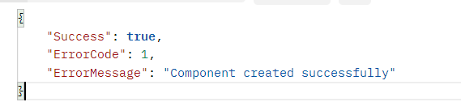

- Create Component Record API: This API will create the records for that component.
Endpoint: /api/MiblockApi/CreateComponentRecord
Method: POST
Headers:
- ms_cms_clientapp: This header specifies the client application making the request and is set to ProgrammingApp.
- Authorization: This header typically handles authentication. It appears to use a bearer token, but you've used @cookieValue as a placeholder. In practice, you would replace @cookieValue with a valid bearer token. Bearer tokens are often used for authentication and authorization purposes, allowing the client to access protected resources.

Note: Authorization should have bearer with the key.
This means that the client application should handle authentication by first logging in to the CMS backend to obtain the necessary token (in this case, the mscmswt cookie value), and then use that token in the Authorization header for subsequent requests.

Body:
Sample Request:
{
"componentName" : "Component 1",
"recordList":[
{
"recordJsonString": "\"{\"title\":\"Create Record 3 API\",\"description\": \"Create Record 3 Description\", \"long-description\": \"Create Record 3 Long Description\"}\""
},
{
"recordJsonString": "\"{\"title\":\"Create Record 4 API\",\"description\": \"Create Record 4 Description\", \"long-description\": \"Create Record 4 Long Description\"}\""
}
]
}

Response:
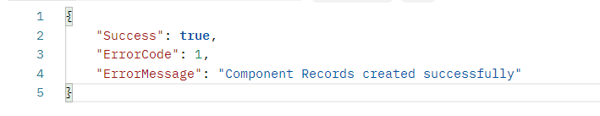
Note: In case, if any of the definition does not have value for component records then need to pass null.
Example: if image definition, does not have any image for a component record then pass null as a value for that definition.

Handling PageLevel, Profile Level and Store Level:
- Page Level: In the request, need to pass the scope id(i.e. id from Component Scope Table mentioned below in the document) and with that need to pass the pages selection on that record.
SelectedValues:
‘selectedpages”: “256983"
- Profile Level: In the request, need to pass the scope id(i.e. id from Component Scope Table mentioned below in the document) and with that need to pass the profile selection on that record.
SelectedValues:
‘selectedprofiles”: “34569"
- Store Level: In the request, need to pass the scope id(i.e. id from Component Scope Table mentioned below in the document) and with that need to pass the store selection on that record.
SelectedValues:
‘selectedStores”: “125698"
Note: You can pass multiple values in selected values by adding “,”. In component record API, need to pass {selectedvalues} only as its for creating component records.
Sample Rquest of creating component :
{
"componentDetails": {
"component": {
"componentName": "Miblock-API-pagelevel-component",
"Scopeid": {scopeId}
},
"definitionList": [
{
"propertyName": "title",
"propertyAliasName": "title",
"showInGrid":true,
"isIdentifier":true
} ],
"recordList":[
{
"recordJsonString": "\"{\"title\": \"Title API 2.1.a\"}\"",
{SelectedValues}
},
{
"recordJsonString": "\"{\"title\": \"Title API 2.6.a\"}\"",
{SelectedValues}
}
]
}
}

Handling SubComponent:
First need to understand how subcomponent and subcomponents records are interlinked with each other. In this link I have shared one example of Subcomponent.
For Subcomponent, we need to add the parent component id of parent component in the request
"component": {
"componentName": "Miblock-ProfileLevel-SubComponent-2-API-08-04-2024",
"Scopeid": 3,
"ParentId":42125 This is parent component id of the component for this child Component(subcomponent)
}
For Component Records, we need to add parent record id, parent component id and main parent componentid
"recordList":[
{
"recordJsonString": "\"{\"title\": \"Title API 2.1.1\", \"header\": \"Header API 2.1.1\",\"short-description\": \"Add short description here\", \"description\": \"Add long description here\", \"gender[]\": [\"Male\"],\"salary[]\": [\"Below 25000\"],\"image\": [\"https://assets.staging.milestoneinternet.com/ramada-encore-doha/rmd-a-couple-of-wolves-in-the-snow.jpg\"],\"image-1\": [\"https://assets.staging.milestoneinternet.com/ramada-encore-doha/1920-x-1080-hd-wallpapers-137.jpg\"],\"birth-date\": \"04/15/1998\",\"country\": \"nepal\"}\"",
"selectedprofiles":"24569",
"ParentRecordId":181678, This will be the id of the parent component record id
"ParentComponentId":42125, This will be component id in which subcomponent is created.
"MainParentComponentid":42125 This will be component id of the main component
}
]
Note: Parent Component ID and Main Parent Component Id will be same for creating the 1st level subcomponent
Summary of Component Json:
- componentName (string,required): The name of the component.
- minRecord (integer): The minimum number of records.
- maxRecord (integer): The maximum number of records.
- IsGlobal (boolean): Indicates whether the component is global.
- ShowInPageStudio (boolean): Indicates whether the component should be shown in the page studio.
- redirectUrl (string): The URL to which the component redirects.
- isUrlBased (boolean): Indicates whether the component is based on a URL.
- isShared (boolean): Indicates whether the component is shared.
- isCrossUserEditRestriction (boolean): Indicates whether there are restrictions on cross-user editing.
- storeLevel (boolean): Indicates whether the component is at the store level.
- pageLevel (boolean): Indicates whether the component is at the page level.
- profileLevel (boolean): Indicates whether the component is at the profile level.
- clientAccessEnabled (boolean): Indicates whether client access is enabled for the component.
- setTimeLimit (boolean): Indicates whether a time limit is set for the component.
- isTaggingEnabled (boolean): Indicates whether tagging is enabled for the component.
- editButtonText (string): The text for the edit button.
- recordText (string): Text related to records.
- scopeId(int): Pass the scope id based on the requirement from the component scope table.
- IsEditableforChildSite(bool):

Summary of Component Definition Json:
- propertyName (string,required): The name of the property.
- propertyAliasName (string,required): An alias name for the property.
- controlName (string): The name of the control associated with the property.
- showInGrid (boolean): Indicates whether the property should be displayed in a grid.
- isMandatory (boolean): Indicates whether the property is mandatory.
- propertyMaxLength (integer): The maximum length of the property value.
- regularExpression (string): A regular expression for validating the property value.
- tooltip (string): Additional information or guidance for the property.
- regExErrorMessage (string): Error message to display if the regular expression validation fails.
- isIdentifier (boolean): Indicates whether the property is an identifier.
- mainIdentifier (boolean): Indicates whether the property is the main identifier.
- isClientEdit (boolean): Indicates whether the property can be edited on the client side.
- resourceTypeName (string): The name of the resource type name need to pass if control name is for image(File).
- propertyValue: The Property Value need to assign with radio button, drop down values

Summary of Component Record Json:
- EnableClientEdit (bool): This property appears to represent a setting related to client-side editing. It is currently initialized as an empty string, which suggests that no specific value has been assigned yet.
- RecordJsonString (string,required): This property seems to be related to a JSON string representing a record. Similarly, it is also initialized as an empty string, indicating that no specific JSON string has been provided yet.
- SelectedPages(string): This property is used to pass the pages to show that record on the specified pages.
- SelectedProfiles(string): This property is used to pass the profile to show that record on the specified profiles.
- SelectedStores(string): This property is used to pass the stores to show that record on the specified stores.

Control Name Table
Text Input
Text Area
Label
Radio Button
Dropdown
ListBox
File
Check Box
Rich Text Editor
Date Picker
Dropdown
String Array
Relationship

Component Scope Table:
Id | Name
1 | Independent
2 | Page Level
3 | Profile Level
4 | Store Level
5 | Shared Content

